EX 1
To study interfacing LED and Push Button Step by step instructions to build the circuit o First, make sure to power off your Arduino with Arduino Board.
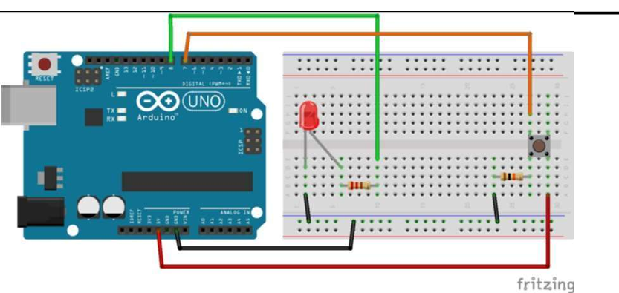

EX 2 To interface Temperature Sensor LM35
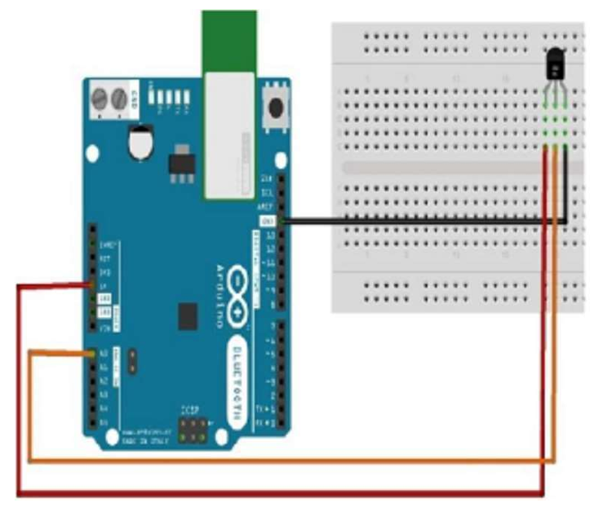

EX 3 To interface Ultrasonic Sensor
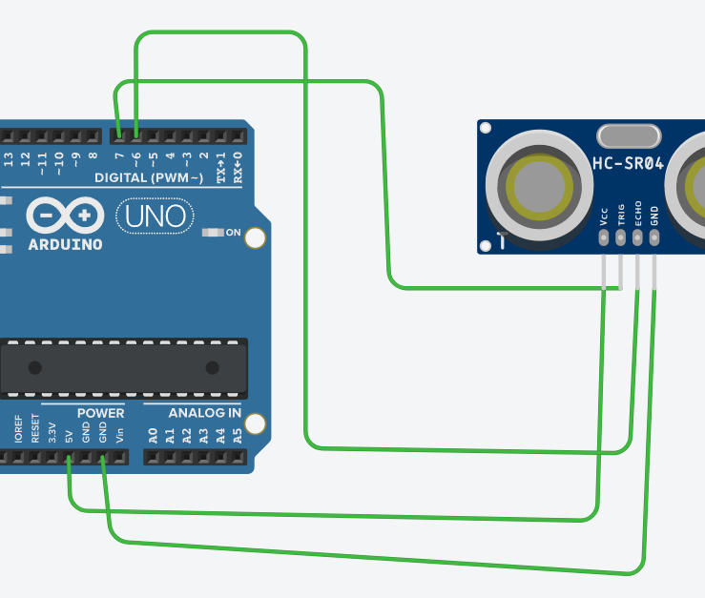

EX4 To interface PIR Sensor
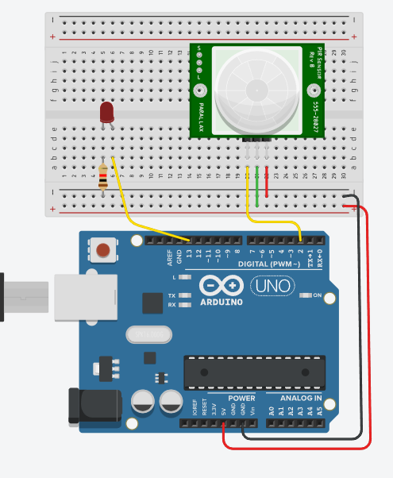

EX5 To interface DHT11: Humidity & Temperature Sensor
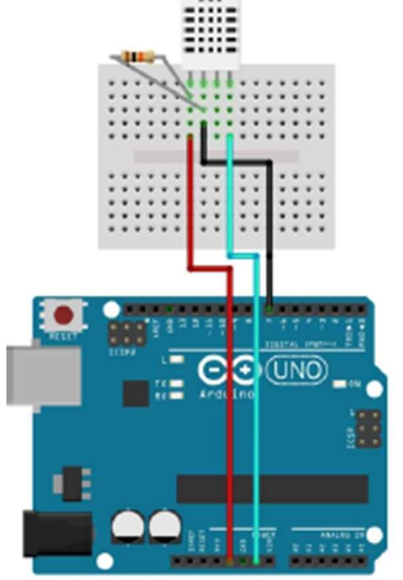

EX6 To interface Raindrop Sensor
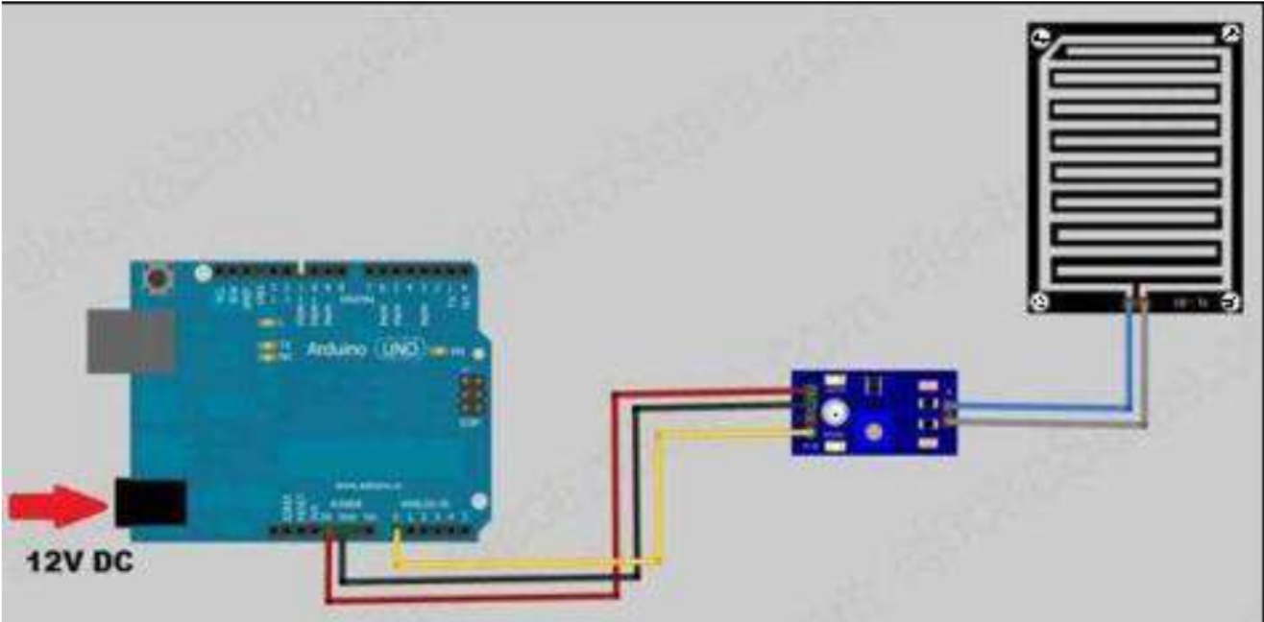

7] To interface Soil Moisture Sensor
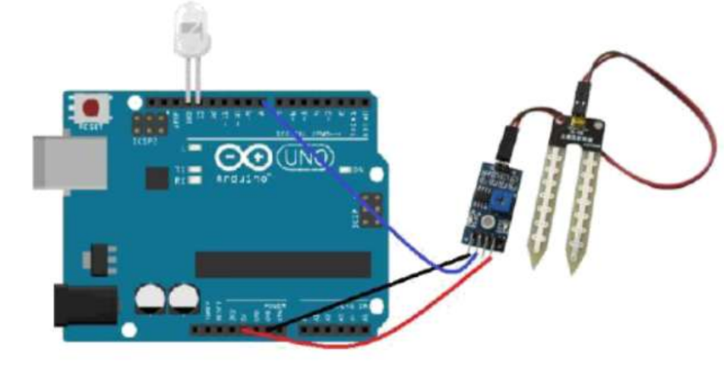

8] To interface LDR Sensor
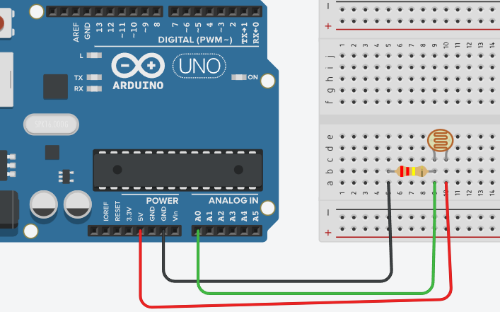

9] To interface DC MOTOR
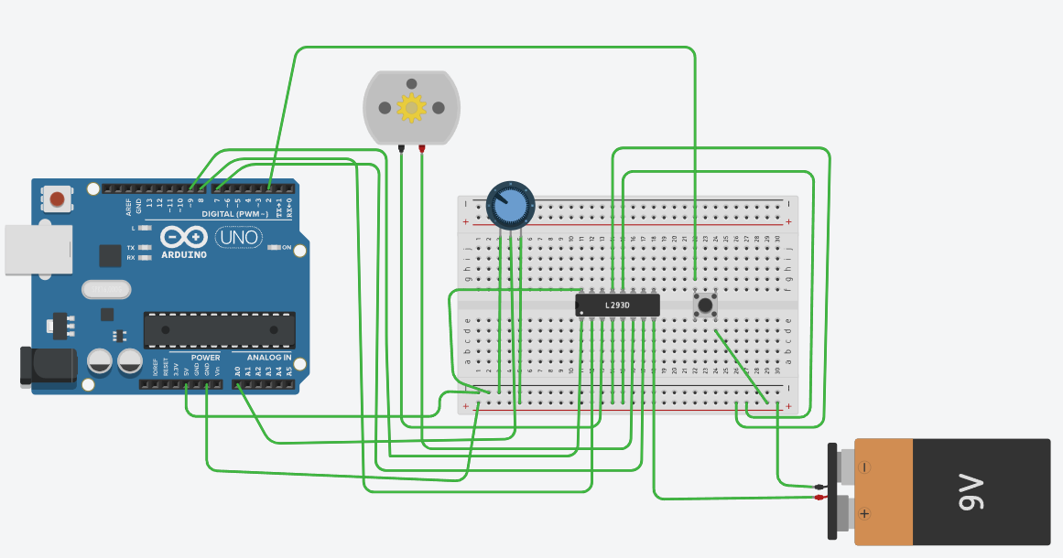

EX10 To interface LCD
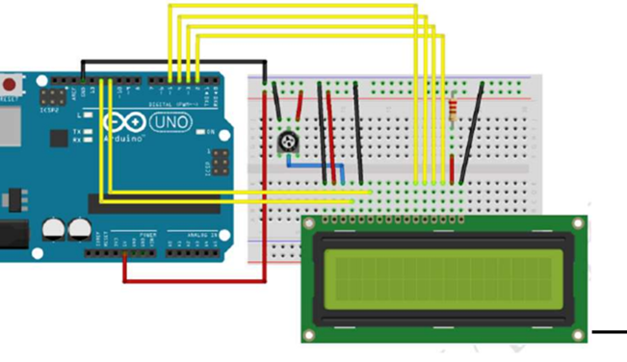
EX13 Get the status of a bulb at a remote place (on the LAN) through web.

